MEMO/10/109
Brussels, 29 March 2010
Consumers at Home in the Internal Market? Questions and Answers on the 2010 Consumer Markets Scoreboard
I. THE SCOREBOARD
What is the Consumer Markets Scoreboard for?
The Scoreboard is a two-part tool put in place to make sure that the EU internal market is working for European consumers by offering them a greater choice of products and services, competitive prices, effective complaints handling and ensuring that they are supported by effective national consumer institutions. Consumers' welfare is after all the 'acid test' for the internal market and for the national markets. If it works for them, it is competitive and innovative.
What is new in the 2010 Scoreboard?
From 2010 the Scoreboard is published twice a year. The spring edition published today examines progress in the integration of the EU retail market from the consumers' perspective. It also monitors improvements in national conditions for consumers (the national consumer environment), reflected e.g. in the consumers' trust in their national consumer authorities and consumer organisations or the effectiveness of handling their consumer complaints.
The autumn edition (planned for October) will screen 50 specific consumer market sectors across the EU to identify those which may be malfunctioning from a consumer point of view. In-depth market studies of the most problematic sectors will then be carried out.
II. CROSS-BORDER COMMERCE
Why should cross-border commerce matter for EU consumers?
Considering the rapid growth of online shopping and border-free travel within the EU, the large EU-wide market – much larger than any domestic market – could be within the consumers' easy reach, resulting in a much wider choice of products and lower prices.
A mystery-shopping study requested by the Commission and published in October 2009 offered concrete evidence that shopping cross-border within the EU could offer genuine savings and a greater choice to consumers (see also IP/09/1564 and MEMO/09/475).
For example, in 13 countries out of 27 and for at least half of all product searches, consumers were able to find an offer in another EU country which was at least 10% cheaper than the best domestic offer (all costs, such as delivery to the consumer's country, included).
For at least 50% of the products, shoppers in 13 EU countries could find online offers in another EU country which they were unable to find on their national market.
How is cross-border commerce doing in the EU?
The proportion of consumers and retailers carrying out cross-border transactions (both online and offline) shows limited growth. In 2009:
- 29% of EU consumers had made at least one cross-border purchase in the past year. The corresponding figure was 25% in 2008 and 26% in 2006.
- 25% of EU retailers sold to at least one other EU country in 2009, compared to 20% in 2008 and 29% in 2006.
- the average amount spent on cross-border purchases was € 795 (almost the same as in 2008).
How is e-commerce doing in the EU?
The internet generates the largest share of distance sales. Online sales in the EU have seen a continuous growth in the past five years. This matters not only for online shoppers: if e-commerce works well, it also puts pressure on offline retailers – what they sell and how much they charge. So successful e-commerce can also benefit those who shop offline.
On average, more than a third of Europeans ordered goods or services online in 2009, but there are significant national differences across the EU: the share varies from 2% in Romania to 66% in the UK (see Figure 1).
The most popular online purchase categories in 2009 were: travel and accommodation (ca. 20% of EU consumers), clothes and sports goods (17%), household goods such as furniture or toys (13%), tickets for events (13%) and media content (e.g. films, music, or books; 12%).
The most important reasons for shopping online were lower prices (50% of online shoppers), certainty about legal rights (49%), convenience (48%), unavailability of the product locally (45%) and a wider choice of goods and services (39%). The top reason for not shopping online is the preference for shopping in person (20% of all EU consumers).

Figure 1: Domestic and cross-border online purchases by country

In contrast to the dynamic growth of e-commerce in general, cross-border e-commerce is lagging behind. As a result, there is growing gap between domestic and cross-border online purchases. In 2009, 34% of EU consumers bought goods or services online from national sellers, compared with 28% in 2008. But only 8% ordered from elsewhere in the EU, compared with 6% in 2008 (see Figure 2).
Figure 2: The growing gap between domestic and cross-border online purchases

The shares of those buying from national and EU retailers also vary significantly from country to country (see Figure 1). Four clusters of countries can be identified:
- small countries where cross-border online purchases are more frequent than domestic ones, probably due to limited domestic choice (Luxembourg, Malta, Cyprus);
- digitally developing countries where e-commerce is, in general, less prevalent (most new EU Member States);
- mature markets where e-commerce is well developed but where significantly more consumers prefer national retailers (the UK, the Netherlands, Sweden, Germany, Denmark, Finland, France);
- linguistically affiliated countries where the levels of domestic and cross-border online purchases are similar. This may be due to a well developed local market and a language connection with neighbouring countries (Austria, Belgium, Ireland).
What is the Commission doing to tackle the barriers to cross-border commerce?
There are legal, regulatory and practical barriers which result in many traders refusing to deliver to some or all EU countries other than their own. An earlier mystery-shopping study shows that over 60% of cross-border orders placed online fail, denying consumers genuine savings and an enhanced choice of products and services which they could have enjoyed on a truly integrated EU-wide market (see MEMO/09/475).
In October 2009, the Commission unveiled a strategy for dismantling barriers in the internal market for consumers. Below is a summary of the action plan (see also IP/09/1564 and MEMO/09/475):
- 1. End the fragmentation of consumer laws.
- 2. Boost cross-border enforcement.
- 3. Tackle unfair commercial practices.
- 4. Promote alternative dispute resolution and the scheme for quick handling of small cross-border claims.
- 5. Simplify and streamline the rules on VAT reporting for distance sellers, on electrical and electronic waste, and on the cross-border management of copyright levies on blank media and recording devices.
- 6. Review rules on exclusive and selective distribution, to see how this can help reduce barriers to online sales.
- 7. End discrimination based on nationality or place of residence.
- 8. Improve cross-border payment systems and logistics.
- 9. Work with industry on the .eu domains and web searches.
- 10. Strengthen market monitoring and information for consumers and traders (e.g. through European Consumer Centres and consumer education tools such as Dolceta).

III. NATIONAL CONDITIONS FOR CONSUMERS
What is the Consumer Environment?
The Scoreboard keeps track of the Consumer Environment Index for all EU countries, which is a measure of the quality of national conditions for consumers. The objective is to create a data set which can be used by EU countries to estimate the impact of policies on the welfare of their citizens.
Key components of the consumer environment are the quality of regulation concerning consumers and businesses, the effectiveness of resolving disputes and handling complaints, consumer trust in authorities, retailers, advertisers and consumer organisations, and the degree of trust in the safety of products on the market.
The key indicators used to calculate the Consumer Environment Index are percentages of consumers (and/or retailers as relevant) who:
- feel adequately protected by existing regulations and law enforcement;
- trust public authorities to protect their consumer rights;
- trust consumer organisations to protect their consumer rights;
- trust sellers / providers to respect their rights;
- did not encounter misleading or fraudulent advertising and offers;
- complained when faced with a problem;
- were satisfied with how their complaint was handled;
- find it easy to resolve disputes thorough alternative-dispute-resolution (ADR) schemes;
- find it easy to resolve disputes through courts;
- do not think that a significant number of products on the markets are unsafe.
How have national conditions for consumers evolved since 2008?
It is clear from the 2009 index that the extreme economic and budgetary conditions have had a negative impact on the consumer policy environments in the EU. Most EU countries (17 countries out of 27) have experienced a decline in their consumer environments (see Figure 3).
Figure 3: Consumer environment in 2009 compared with 2008
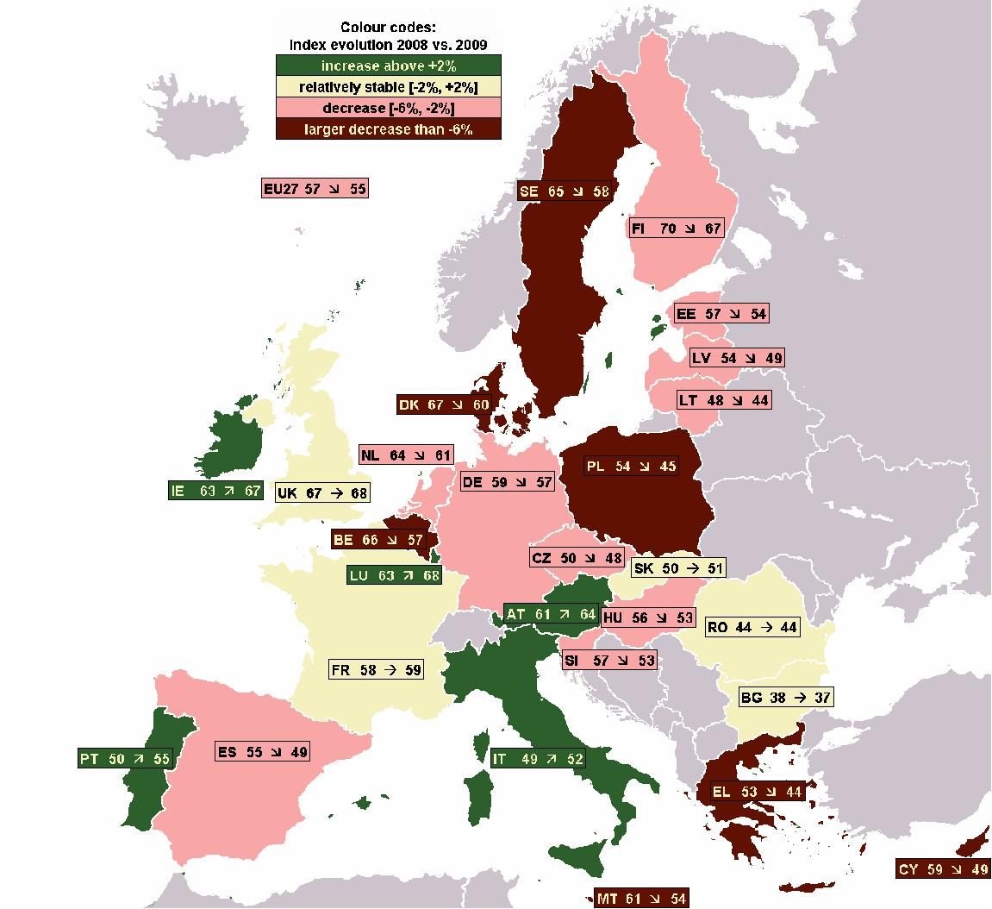
Nevertheless, 8 countries have improved their result compared with 2008. These were: Portugal, Luxembourg, Ireland, Italy Austria, France, Slovakia and United Kingdom. The first five () have seen a growth of more than 2 percentage points.
The top five countries with the highest index values in 2009 were: the United Kingdom, Luxembourg, Finland, Ireland and Austria.
The full report contains detailed country-specific data.
What do retailers know about consumer rights?
The Scoreboard reveals that retailers are overconfident about their knowledge of consumer legislation. In a survey, more than eight out of ten retailers said that they were well informed about consumer laws. However, when tested, only about one in four gave correct answers to questions on consumer rights relevant for their businesses, for example about the length of the cooling-off period for distant sales and the legal period for returning of a defective product.
How widespread are misleading and fraudulent practices?
Retailers' and consumers views differ widely as to the frequency of misleading or fraudulent advertising. More than half of consumers spotted misleading or fraudulent advertising, but only over a quarter of retailers did.
III. CONSUMER AFFORDABILITY
What is consumer affordability?
Consumer Affordability measured in the Scoreboard takes into account both the relative levels of income and the cost of living in each EU country.
How affordable is life for consumers across the EU?
The ability of consumers to afford goods and services varies greatly across the EU: Six countries are more than half below the EU average while one country is more that 50% above the EU average (see Figure 4).
Figure 4: Consumer affordability in the EU
Strikingly, life for consumers is more affordable in the richer EU countries, despite higher price levels: Luxembourg is by far the most affordable country, followed by the UK, Cyprus, the Netherlands and Austria in the top five.
IV. FOLLOW-UP TO EARLIER SCOREBOARD FINDINGS
Which problems were identified in earlier Scoreboard editions?
The 2009 Scoreboard screened more than 20 goods and services sectors against five key consumer indicators: prices, switching, satisfaction, complaints and safety. It also analysed the integration of the EU retail market and national consumer environments.
Three service markets in particular were found to be underperforming for consumers: energy, banking and urban transport. The 2009 Scoreboard also found that cross-border commerce was stalling in the EU (see IP/09/202).
What did the Commission do about these findings?
The findings of the 2009 Scoreboard have triggered several in-depth market studies: on cross-border e-commerce, on retail financial services and on the retail electricity market.
a) Cross-border e-commerce
An in-depth study, including a mystery-shopping exercise, was published in October 2009. A summary of the results and of the policy response has been outlined in Section II above (see also IP/09/1564 and MEMO/09/475).
b) Retail financial services
The study on retail financial services revealed several problems for consumers. For instance, it found that: (a) pre-contractual information is often incomprehensible, (b) financial advice may be unreliable, (c) fee structures of current accounts are often opaque, (d) in some EU countries, consumers pay considerably more for current accounts than in others, and (e) for current bank accounts, switching rates remain low at 9%, compared e.g. with 25% for car insurance. The study has provided key evidence for the Commission’s policy work in the area of retail financial services (see IP/09/1341 and MEMO/09/402).
c) Retail electricity market
The 2009 Scoreboard identified the energy market as one of the most problematic for EU consumers: less than two thirds of consumers were satisfied with their energy supplier, about 60% of consumers reported price increases from their energy supplier, while only 3-4% saw price decreases, and the market scored particularly badly in terms of the comparability of offers and the ease of switching (energy was found to be the sector where consumers were least likely to switch: only 7% switched gas supplier, and 8% electricity supplier).
As a follow-up, the Commission is conducting an in-depth study of the retail electricity market, which will be released later in 2010.
The Commission is also leading the work on better energy bills, designed to improve the information for consumers, including comparability between providers, and facilitate switching. Both industry and consumer organisations have been involved in the process, In October 2009, this resulted in the Citizens’ Energy Forum endorsing recommendations for user-friendly bills (see IP/09/1418 and MEMO/09/429).
V. MORE INFORMATION
- The full report, including detailed country-specific data: http://ec.europa.eu/consumers/strategy/facts_en.htm#3CMS
- Eurobarometer surveys on consumers’ and retailers’ attitudes: http://ec.europa.eu/consumers/strategy/facts_eurobar_en.htm
- The European Commission’s consumer policy: http://ec.europa.eu/consumers/index_en.htm
- See also IP/10/384

Commission Communication on Cross-Border Business to Consumer e-Commerce in the EU: http://ec.europa.eu/consumers/strategy/docs/COM_2009_0557_4_en.pdf
Commission Communication on Cross-Border Business to Consumer e-Commerce in the EU: http://ec.europa.eu/consumers/strategy/docs/COM_2009_0557_4_en.pdf
Commission Communication on Cross-Border Business to Consumer e-Commerce in the EU: http://ec.europa.eu/consumers/strategy/docs/COM_2009_0557_4_en.pdf
Commission Staff Working Document on the follow-up in Retail Financial Services to the Consumer Markets Scoreboard: http://ec.europa.eu/consumers/rights/docs/swd_retail_fin_services_en.pdf

